PRACTICAL 9:
Program1:
Code:
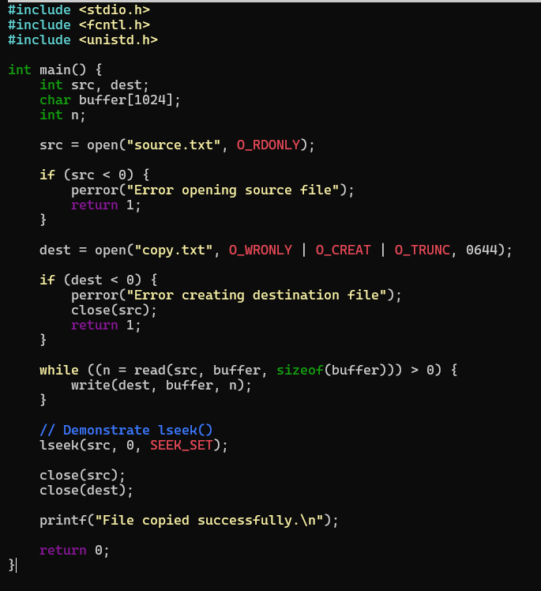
Output:
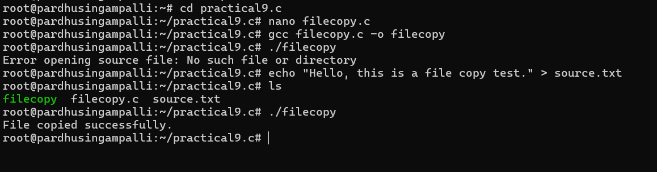

PROGRAM 2:
Code:
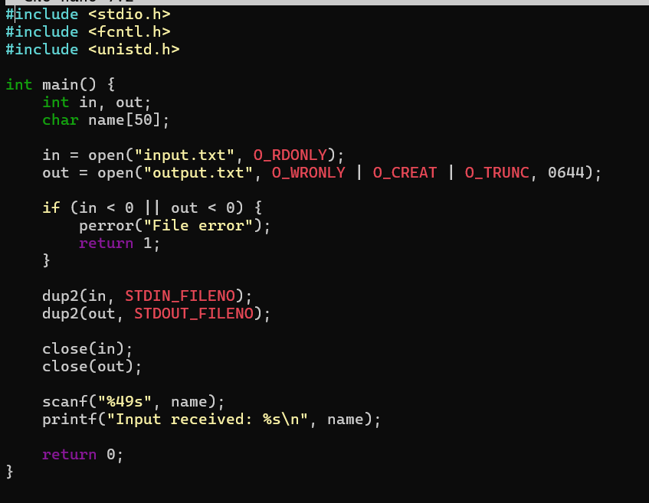
Output: